**Wien Bridge**

Wien bridge is used to search for an unknown impedance by connecting that unknown impedance in series or parallel of the terminal to which it is connected. It is generally not used to measure capacitors because of the complexity of its solution at null.

Since it is a frequency-dependent null network, its general application lies in the design of frequency-based applications such as the design of tuned band-pass and band-reject filters and as oscillators. It is also used for precision measurement of capacitance in terms of resistance and frequency, and is also used to measure lower audio frequencies between 20Hz to 20kHz.

One application that is widely used with Wien Bridge is as oscillator by connecting it with an op-amp. Wien Bridge Oscillator is a type of phase-shift oscillator that is based from Wien Bridge. This oscillator behaves like a high-pass filter or a low-pass filter, since it oscillates within a set of frequency.

Since it is frequency-dependent, it will surely have its high and low frequencies. Therefore, there exists a particular frequency at which the values of the resistance and the capacitance becomes equal to each other where it will produce the maximum output voltage. This frequency is referred to as resonant frequency.

Its name also exists in Maxwell Bridge (other name: Maxwell-Wien Bridge), it is different in its calculation and application.

Figure 1 below shows Wien Bridge. Its name is also widely known as Wien Bridge Oscillator, where it is a type of a phase-shift oscillator.

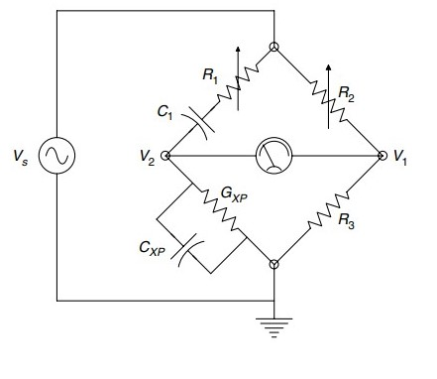

Figure Wien Bridge